Parameters | Values
Platform | NS2.29
Propagation Model | Two way ground
Network Topologies | Random
Transmission Range | 250m
Interference Range | 150m
Frequency | 2.472e9Hz
Traffic Type | Random Waypoint
Channels | 1(increase the number of channels-3)
Packet Size | 512bits
Simulation Time | 200s
Initial Energy of the node | 100j
Transport Type | TCP
Data Rate | 11Mb
Mac | 802.11
Area | 1000m X 1000m
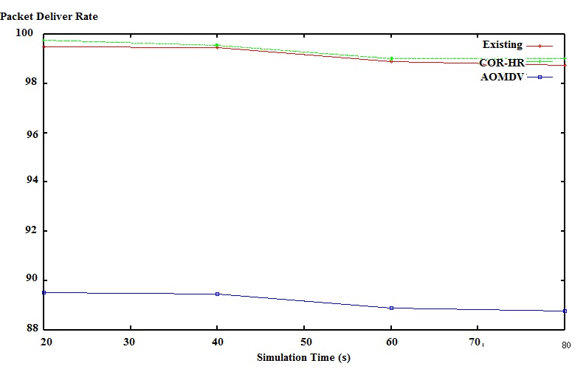
Table 1: Simulation setting for COR-HR

Figure: Packet delivery ratio Vs Simulation time

